# Rademacher distribution

Def

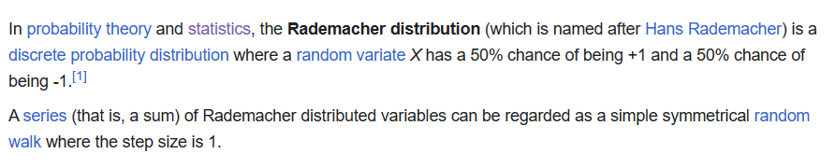

$$50\%$$ => $$1$$

$$50\%$$ => $$−1$$

Support

$$\left\{−1,1\right\}$$

PMF

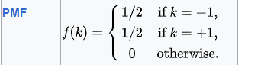

CDF

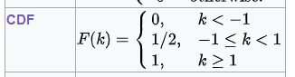

Expected Value

正在插入影像...

Variance

正在插入影像...

Median



Mode

正在插入影像...

Skewness



Entropy



MGF



CF



Ref

[Rademacher distribution - Wikipedia](https://en.wikipedia.org/wiki/Rademacher_distribution)